COMMON COURSE ASSIGNMENT FORMAT

A. Assignment Information
Department | [Department Name — to be filled by faculty]
Programme | [Programme, e.g., B.Tech / B.Sc — to be filled by faculty]
Course Code & Course Name | CSA09 – Programming in Java
Academic Year / Batch | 2024
Faculty Name | Padmakala S
Assignment Title | Real-Time Concurrent Bank Fund-Transfer & Ledger System — Preventing the “Double-Spend / Lost-Update” Bug
Date of Issue | 01/09/2026
Date of Submission | 01/09/2026
Maximum Marks | 100
Course Outcome(s) – CO | CO1, CO2, CO3, CO5 (core) and CO4 (bonus)
Bloom's Taxonomy Level | L3–L6 (Apply, Analyze, Evaluate, Create)
SDG Mapping (SDG 1-17) | SDG 8 – Decent Work and Economic Growth (resilient financial infrastructure)
Industry / Societal Relevance | Lost-update and double-spend defects caused by unsynchronized concurrent access to shared balances are real, recurring production incidents in banking, fintech, and payment-gateway systems; this assignment reproduces the exact class of concurrency defect financial-systems engineers are hired to prevent.

B. Assignment Problem / Challenge
This assignment presents a realistic computing/software-engineering problem related to the Course Outcomes of CSA09 – Programming in Java. It requires students to apply course concepts rather than reproduce theory, identify and analyze the problem, consider requirements and constraints, develop and compare alternative solutions, use relevant modern computing tools, interpret results, and make and justify engineering decisions, while considering appropriate technical, economic, societal, ethical, safety or sustainability factors.

C. Problem Statement
Problem / Case / Design Challenge:
You have joined the core-banking engineering team of a digital bank. During peak hours, customers report a critical production bug: when a customer (or an attacker) fires multiple simultaneous fund-transfer/withdrawal requests against the same account within milliseconds of each other, the account balance goes negative even though each individual request checked that sufficient funds were available before debiting — a classic “lost update” / double-spend defect. Separately, transfers between two accounts have started to hang indefinitely under load. As the engineer responsible, you must redesign, implement, and prove the correctness of the transfer/ledger core in Java.
Part A — Domain Modeling (CO1: OOP)
Design classes for Bank, Customer, Transaction, and an Account hierarchy where account types (SavingsAccount, CurrentAccount) extend a base Account class and override an applyInterestOrFee() (or similar) method (inheritance + polymorphism). Use encapsulation properly — balance must never be a public mutable field; all changes must go through controlled methods.
Part B — Ledger using Collections (CO2)
Maintain all accounts of the bank using an appropriate Collection Framework structure (e.g., Map<String, Account> keyed by account number), and a running transaction ledger using a List<Transaction>. Use Iterators and Generics correctly. Justify your choice of collection over alternatives (e.g., HashMap vs ConcurrentHashMap vs TreeMap for account lookup).
Part C — The Core Challenge: Concurrency + Exception Handling (CO3)
Simulate at least 20 concurrent threads, each representing an independent withdrawal or transfer request, hitting a small shared pool of accounts (so several threads target the same account, and several perform transfers between the same pair of accounts in opposite directions).
- First implement withdraw()/transfer() WITHOUT synchronization and run the stress test — capture output/log evidence proving the balance goes negative or an incorrect final balance results (this is your “before” evidence: the lost-update bug).
- Then fix it using appropriate thread-safety techniques (synchronized methods/blocks, or explicit Lock objects) so the check-then-debit sequence is atomic and the balance can never go negative and never loses an update.
- For transfer(accountA, accountB, amount), you must lock BOTH accounts before moving funds. Naively locking “from-account then to-account” causes a classic deadlock when two threads transfer in opposite directions at the same time (Thread-1 locks A then waits for B, Thread-2 locks B then waits for A). First demonstrate this deadlock occurring (e.g., via a thread-dump showing both threads BLOCKED), then fix it using a consistent lock-ordering strategy (e.g., always lock the account with the smaller account number first) and prove the deadlock no longer occurs under the same stress test.
- Define and correctly use custom checked exceptions: InsufficientBalanceException, InvalidAccountException, AccountFrozenException, and TransactionLimitExceededException. If a transfer fails partway (e.g., the credit step throws after the debit step succeeded), the debited amount must be rolled back — demonstrate this recovery in your output.

Part D — Persistence with JDBC (CO5)
Connect to a database (MySQL/PostgreSQL) via JDBC. Every successful transaction (deposit, withdrawal, transfer) must be inserted into a transactions table, account balances must be updated, and you must support querying a customer's mini-statement (recent transaction history) — using PreparedStatement (not string-concatenated SQL; explain why in your report). Show the database table's before/after state as evidence, including a case where a failed transfer correctly leaves the database balances unchanged.
Part E — Bonus, Optional (CO4)
Build a minimal Swing/AWT teller dashboard that lists all accounts with live-updating balances and a running transaction counter as the concurrent stress test executes, using AWT/Swing event handling and layout managers.
Assumptions students may state:
- Concurrent load can be simulated in-process using Java threads (no external load-testing tool required).
- Any relational database (MySQL/PostgreSQL/SQLite) may be used, provided JDBC connectivity and SQL operations are demonstrated.
- Interest computation, KYC, and real payment-network integration are out of scope — the focus is strictly on concurrency-safe balance updates and transactional integrity.

D. Requirements and Constraints
Functional requirements:
- Model accounts, customers, and transactions using proper OOP design (inheritance, polymorphism, encapsulation).
- Maintain the account directory and transaction ledger using the Collection Framework with generics and iterators.
- Support concurrent withdrawal and transfer attempts from multiple threads against a shared, small pool of accounts.
- Guarantee balances never go negative and no update is ever lost, with atomic check-then-debit semantics.
- Guarantee two-account transfers never deadlock, using a documented lock-ordering strategy.
- Handle all failure conditions (insufficient balance, invalid account, frozen account, limit exceeded) through custom exceptions with correct rollback on partial failure.
- Persist all transactions and updated balances via JDBC with parameterized queries.
- Maintain a transaction audit log file using Java I/O.
Non-functional requirements / constraints:
- Thread-safety: zero negative balances and zero lost updates under concurrent load, demonstrated with a stress test showing both the unsynchronized (buggy) and synchronized (fixed) runs.
- Liveness: zero deadlocks under concurrent bidirectional transfers, demonstrated with both the naive (deadlocking) and lock-ordered (fixed) versions.
- Consistency/atomicity: a transfer either fully succeeds (both legs) or fully fails (neither leg applied); no partial transfer may persist in memory or in the database.
- Scalability (discussion only, not implementation): briefly discuss how the design would extend to multiple application servers sharing one database (e.g., DB-level row locking / SELECT ... FOR UPDATE or optimistic concurrency versus JVM-level synchronization).
- Security: discuss, at a conceptual level, how account and transaction data would be protected and audited (no requirement to implement encryption).

E. Student Work
1. Problem Understanding and Formulation
Explain: what the lost-update/double-spend problem is and why it occurs at the code level; what the transfer-deadlock problem is and why it occurs; the expected outcome (balances never go negative, no update is lost, no deadlock); what data/inputs are available (number of accounts, opening balances, number of simulated concurrent threads); and the assumptions and constraints listed in Section D that you are adopting.
Problem Understanding:
The project addresses a concurrency problem in a digital banking system. When multiple withdrawal requests access the same account simultaneously, each thread may check the same balance before another thread updates it. This creates a lost-update/double-spend problem and may result in a negative account balance.
The transfer problem occurs when two threads transfer money between the same two accounts in opposite directions. If one thread locks Account A and waits for Account B while another locks Account B and waits for Account A, both threads wait indefinitely, creating a deadlock.
The expected solution is to ensure that account balances never become negative, updates are not lost, transfers do not deadlock, and failed operations are correctly rolled back.
The implementation used a small set of bank accounts and at least 20 concurrent threads to simulate multiple withdrawal and transfer requests.
Inputs used:
- Accounts: A301 and A302
- Initial balance: ₹8,000 for each account in the database test
- Concurrent withdrawal threads: 20
- Transfer amount in JDBC test: ₹750
- Rollback demonstration initial balance: ₹1,200
The project adopts the given constraints of thread safety, deadlock prevention, atomicity, exception handling, JDBC persistence, audit logging, and responsible handling of banking data.

2. Application of Course Knowledge
Identify and apply: OOP principles (classes, inheritance, polymorphism, encapsulation); Collection Framework interfaces and generics; the Java thread model, thread priorities, synchronization and inter-thread communication; exception-handling constructs (try/catch/finally, custom exceptions); and JDBC connectivity concepts (Connection, PreparedStatement, ResultSet). Show the relevant code snippets and explain the reasoning behind each design choice.
Ans)
The project applies several Java concepts.
OOP:
Classes such as Bank, Customer, Account, SavingsAccount, CurrentAccount and Transaction are used to model the banking domain. Inheritance is used for different account types. Polymorphism is demonstrated through the overridden applyInterestOrFee() method. Encapsulation is maintained by keeping account balance private and changing it only through controlled methods.
Collections:
A Map<String, Account> is used for account lookup using account numbers. A List<Transaction> is used as the transaction ledger. Generics provide type safety while using the Collection Framework.
Multithreading:
Java threads and executor services are used to simulate 20 concurrent banking requests. The unsafe implementation demonstrates the concurrency bug, while synchronization is used in the fixed implementation.
Exception Handling:
Custom checked exceptions such as InsufficientBalanceException, InvalidAccountException, AccountFrozenException, and TransactionLimitExceededException are used to handle banking failures.
JDBC:
The project uses JDBC classes such as Connection, PreparedStatement, and ResultSet to connect Java with MySQL, update account balances, insert transactions, and retrieve transaction history.

3. Solution / Design / Methodology
Develop the account/ledger engine as described in Parts A–D of Section C. Where appropriate, compare at least two possible synchronization strategies (e.g., synchronized blocks vs. ReentrantLock) and at least two lock-ordering strategies for deadlock avoidance before settling on one.
The solution was developed in multiple stages.
First, an unsafe withdrawal implementation was created without synchronization. Twenty concurrent threads attempted withdrawals against the same account. The final balance became negative, demonstrating the lost-update/double-spend problem.
Next, synchronization was introduced so that the balance check and debit operation were performed atomically. The fixed test produced a final balance of ₹0.00 and rejected excess withdrawal requests.
For transfers, a naive locking approach was tested first. One thread locked A301 and another locked A302, producing a deadlock. The solution was to use consistent lock ordering. Accounts are locked according to their account number, so both threads acquire locks in the same order.
For synchronization strategies, synchronized methods/blocks are simpler and easy to understand, while ReentrantLock provides additional features such as explicit lock/unlock control and try-lock functionality. The project selected synchronization/explicit account locking because it is simple and suitable for the prototype.
For deadlock avoidance, two approaches were considered: acquiring locks in arbitrary transfer order and acquiring locks using a consistent account-number order. The second approach was selected because it prevents circular waiting.
A rollback mechanism was also implemented. When a failure occurs after debit, the debit is reversed so that the original balance is restored.

4. Use of Modern Tools
Use an IDE (e.g., IntelliJ IDEA/Eclipse), JDK, a relational database with a JDBC driver, and a version-control tool (Git) to manage your source code. Provide evidence of tool usage (screenshots, commit history, or console output) as required by the assignment format.
The following tools were used:
Tool | Purpose
Java JDK 21.0.4 | Compiling and executing Java programs
Visual Studio Code | Writing and managing Java source files
MySQL Workbench | Creating and checking the database
MySQL | Persistent storage of accounts and transactions
MySQL Connector/J 9.1.0 | JDBC connectivity between Java and MySQL
Git/GitHub | Source-code/version-control management
Java I/O | Maintaining the audit log

5. Results and Validation
Present: console output/log excerpts showing the negative-balance/lost-update bug occurring in the unsynchronized version; console/thread-dump excerpts showing the deadlock occurring in the naive two-account-lock version; console output/log excerpts showing correct, deadlock-free behaviour in the fixed version; before/after screenshots of the database table; and, if attempted, a screenshot of the GUI teller dashboard. Validate explicitly whether the stated requirements (no negative balance, no lost update, no deadlock, correct rollback on partial failure) are satisfied.
Before Fix – Unsafe Withdrawal
The unsynchronized test used 20 concurrent threads. The final balance became negative:
UNSAFE FINAL BALANCE = ₹-650.00
This demonstrates the lost-update/double-spend problem because multiple threads were able to pass the balance check before updating the account.
After Fix – Synchronized Withdrawal
The synchronized implementation produced:
FIXED FINAL BALANCE = ₹0.00
Expected: ₹0.00
Excess withdrawal requests were rejected with:
Insufficient balance
Therefore, the fixed implementation prevented the negative-balance problem.
Deadlock Test
The naive transfer implementation produced:
NAIVE DEADLOCK TEST
pool-3-thread-1 locked A301
pool-3-thread-2 locked A302
DEADLOCK DETECTED
This confirms that opposite lock acquisition can produce a deadlock.
Deadlock Prevention
The lock-ordered implementation produced:
All lock-ordered transfers completed = true
A301 = ₹8000.00
A302 = ₹8000.00
No deadlock because locks are acquired by account-number order.
Therefore, the consistent lock-ordering strategy successfully prevented deadlock.
Rollback
The rollback test produced:
Debit succeeded. R301 = ₹800.0
Failure detected -> rollback performed.
R301 after rollback = ₹1200.0
Original balance = ₹1200.0
This proves that the original balance was restored after the simulated failure.
JDBC Validation
The Java application successfully connected to MySQL:
JDBC connection successful.
Before the database transfer:
A301 | Arjun | ₹8000.00
A302 | Sneha | ₹8000.00
After transferring ₹750:
A301 | Arjun | ₹7250.00
A302 | Sneha | ₹8750.00
The transaction was also recorded in the transactions table.

Figure 1: Unsynchronized withdrawal demonstrating the lost-update/double-spend problem
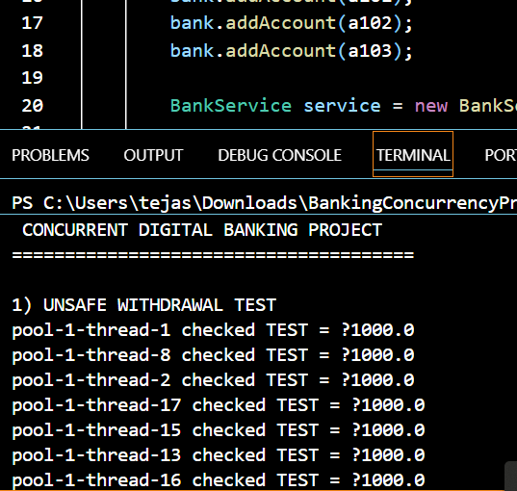
Figure 2: Synchronized withdrawal after applying thread safety
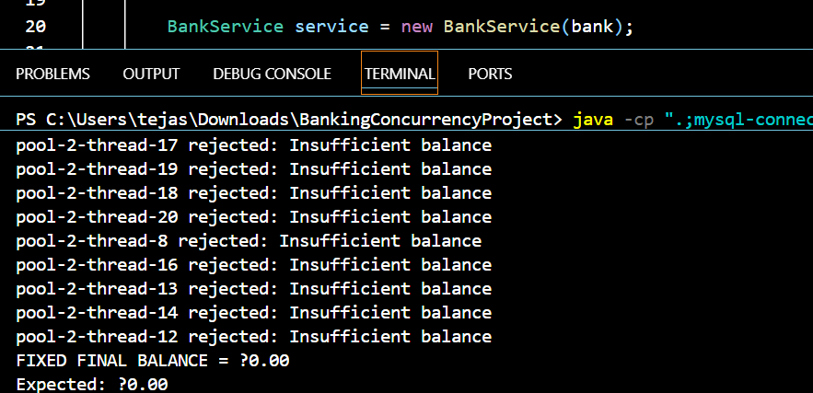
Figure 3: Naive two-account locking resulting in deadlock
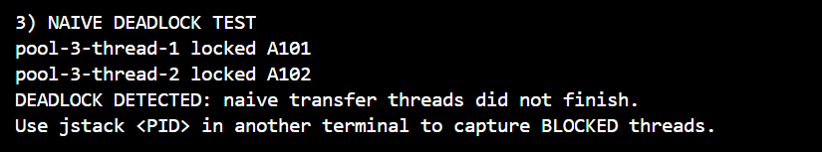
Figure 4: Deadlock prevention using consistent lock ordering

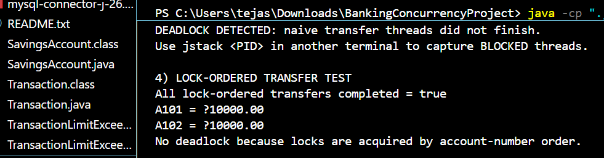
Figure 5: Rollback after simulated transaction failure
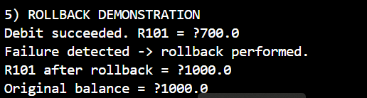
Figure 6: Successful Java-JDBC-MySQL connection

Figure 7: Updated account balances after database transfer
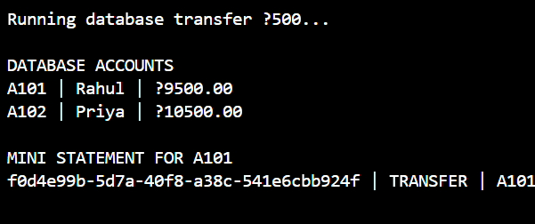
Figure 8: Transaction record stored in MySQL
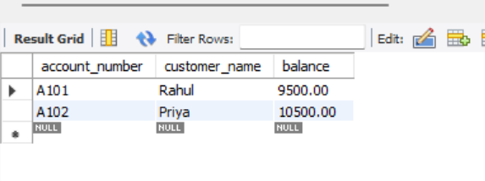
Figure 9: Java audit log recording banking activity
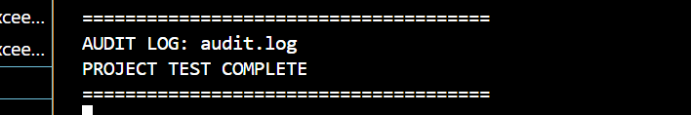
6. Analysis and Engineering Decision
Compare the synchronization and lock-ordering strategies you evaluated; discuss their trade-offs (throughput vs. simplicity vs. contention vs. risk of deadlock); explain why your final approach was selected; and justify the decision using the timing/output evidence you gathered.
Two synchronization approaches were considered: synchronized methods/blocks and explicit ReentrantLock objects. Synchronized methods are simpler and automatically release the monitor when execution leaves the synchronized section. ReentrantLock provides more control but requires careful lock management.
The project selected synchronized/explicit account locking because the banking prototype requires clear and reliable mutual exclusion.
For deadlock prevention, arbitrary lock acquisition was rejected because it produced a deadlock during the stress test. Consistent account-number lock ordering was selected because both threads acquire multiple account locks in the same order, eliminating circular waiting.
The output evidence supports this decision. The unsafe version produced a negative balance of ₹-650.00, while the synchronized version produced ₹0.00. The naive transfer produced a deadlock, while the lock-ordered version completed successfully.

7. Broader Considerations
Discuss the real-world impact of shipping this bug to a banking system: financial loss and regulatory exposure, societal/customer-trust impact, and the ethical/professional responsibility of an engineer to rigorously test concurrent code paths handling money before release.
A concurrency defect in a banking application can cause serious financial loss because customers may withdraw or transfer more money than their actual balance. Such defects can also result in incorrect account records, customer complaints, regulatory problems, and loss of trust.
From a societal perspective, customers expect banking systems to maintain accurate and reliable financial records. Therefore, developers have an ethical and professional responsibility to test concurrent operations carefully before deploying financial software.
Security and auditing are also important. Transaction records should be protected from unauthorized access and modifications, and important financial activities should be logged for auditing and investigation.
8. Conclusion
Summarize the proposed solution, major findings from the before/after comparison, the extent to which requirements were met, limitations of your implementation, and possible improvements (e.g., moving to database-level transactions with SELECT ... FOR UPDATE, or a distributed-transaction/saga pattern for multi-server deployments).
The project successfully implemented a concurrency-safe digital banking core in Java. The initial unsynchronized implementation demonstrated the lost-update/double-spend problem by producing a negative balance. The synchronized implementation prevented this problem and produced the expected final balance.
The project also demonstrated the classic two-account deadlock using naive locking. This was resolved using consistent account-number lock ordering. The rollback demonstration showed that a failed operation can restore the original balance.
JDBC integration with MySQL was successfully completed. Account balances were updated and the ₹750 transfer was stored in the transactions table. An audit log was also generated.
The main limitation is that the implementation is a prototype running within one Java process. In a real multi-server banking system, database-level transactions, row locking such as SELECT ... FOR UPDATE, optimistic concurrency control, or distributed transaction patterns would be required.
9. Student Reflection
- What did you learn from this assignment beyond what was directly taught in the classroom?
I learned that multithreaded programs can produce incorrect results even when the individual operations appear correct. I understood the importance of atomic check-then-update operations, synchronization, deadlock prevention and rollback. I also learned how Java applications communicate with MySQL using JDBC and how transaction records can be persisted and audited.
- If you were given additional time/resources, what would you improve and why?
- With additional time and resources, I would improve the project by adding a Swing-based teller dashboard, stronger database transaction management, better authentication and authorization, automated unit and stress tests, and database-level locking. I would also test the system with multiple application servers to understand distributed concurrency problems.

10. References
Use an appropriate citation format and acknowledge all external sources, datasets, standards, software, libraries (e.g., JDBC driver), and any AI-assisted tools used.
- Oracle Java Documentation – Java Language and Concurrency concepts.
- Oracle JDBC Documentation – JDBC API and database connectivity.
- MySQL Documentation – MySQL database and transaction concepts.
- MySQL Connector/J Documentation – JDBC driver for MySQL.
- Visual Studio Code Documentation – Java development environment.
- Git Documentation – Version control.
- OpenAI ChatGPT – AI-assisted support for understanding Java, JDBC, concurrency and project documentation.

F. Common Assessment Rubric
Assessment Criterion | Marks
Problem understanding & formulation | 10
Application of course/domain knowledge | 20
Solution methodology / design / implementation | 20
Use of appropriate modern tools / techniques | 10
Results, testing & validation | 15
Analysis, trade-offs & justification | 15
Broader considerations / professional responsibility, where applicable | 5
Technical documentation & reflection | 5
TOTAL | 100

G. CO–PO–Assessment Mapping
Assessment Component | CO | PO(s) | Bloom's Level | Marks
Problem formulation | CO1 | [Faculty to map] | L3/L4 | 10
Application of knowledge | CO1, CO2 | [Faculty to map] | L3/L4 | 20
Solution / Design / Implementation | CO1, CO2, CO3 | [Faculty to map] | L4/L5/L6 | 20
Modern tool usage (multithreading + JDBC) | CO3, CO5 | [Faculty to map] | L3/L4 | 10
Validation | CO3, CO5 | [Faculty to map] | L4/L5 | 15
Analysis & justification | CO3 | [Faculty to map] | L4/L5 | 15
Broader considerations | CO1–CO5 | [Faculty to map] | L4/L5 | 5
Documentation & reflection | CO1–CO5 | [Faculty to map] | L3/L4 | 5
Note: PO mapping is institution/programme-specific and left for the faculty to complete based on the department's approved PO framework. CO mapping above is pre-filled based on the CSA09 syllabus Course Outcomes (CO1: OOP design; CO2: Collections Framework; CO3: Exception handling & multithreading; CO4: GUI/event handling — bonus part; CO5: JDBC connectivity).

H. Faculty Evaluation & Continuous Improvement
CO Attainment
Performance Level | Criterion
Level 3 | ≥ 70%
Level 2 | 60–69%
Level 1 | 50–59%
Level 0 | < 50%
Target CO Attainment: ______________
Actual CO Attainment: ______________
Faculty Analysis
Areas in which students performed well: ______________________________________________
Areas requiring improvement: ______________________________________________
Corrective / Improvement Action: ______________________________________________
Action to be implemented in the next offering: ______________________________________________

